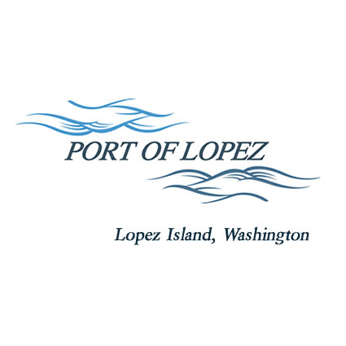

672 Airport Road, P.O. Box 907
Lopez Island, WA 98261
360.468.4116
wcatlin@portofolopez.com
www.portofolopez.com

Port of Lopez Public Hearing and Meeting Agenda

November 13th, 2025, 4:00 P.M.

This Meeting will be on Zoom and in-person at the airport terminal
Join Zoom Meeting
https://us02web.zoom.us/j/82360850819?pwd=QHiBaxh0C4j8ZMoNFomPBYjlEKLmgO.1
Meeting ID: 823 6085 0819
Passcode: 575403

Call to Order

PUBLIC HEARING TO APPROVE 2026 Budget and Levy Rate
Public Commentary

Close of Public Hearing

Budget and Levy Approval for 2026
- Board Review and Approve 2026 Port Budget
- Approve Resolution 2025-4, Adopting levy rate for 2026

ONGOING BUSINESS
- DOWL Projects:
- Blackwater updates
- Bayview Park Progress

MONTHLY BUSINESS
- Approval of Previous Minutes
- Approval of Vouchers, Payroll, and Financial Reports

MONTHLY REPORTS
- Correspondence
- Manager’s Report
- Commissioner’s Reports
- Task/Project list review

NEW BUSINESS
            - New Hangar Allocation Policy discussion
            - WSCAA Conference debrief
            - North Airport Property Discussion: Current tenant, Lopez Grain Center Proposition

AGENDA AMENDMENTS
ADJOURNMENT: Next Regular Meeting December 11th, 2025

