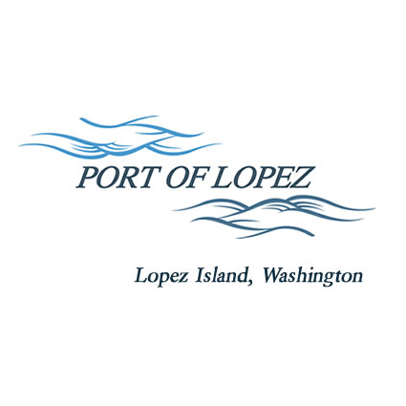

672 Airport Road, P.O. Box 907
Lopez Island, WA 98261
360.468.4116
wcatlin@portofolopez.com
www.portofolopez.com

Port of Lopez Regular Monthly Meeting Agenda

December 11th, 2025, 4:00 P.M.

This Meeting will be on Zoom and in-person at the airport terminal
Join Zoom Meeting
https://us02web.zoom.us/j/86075094042?pwd=OmdbBmbarj0DxMbbWbjcyKfsJqFAxU.1
Meeting ID: 860 7509 4042
Passcode: 754517

CALL TO ORDER

ONGOING BUSINESS
- DOWL Projects:
- Blackwater updates
- Bayview Park Progress
- New Hangar Allocation and Waitlist Policy Discussion

Public Commentary

MONTHLY BUSINESS
- Approval of Previous Minutes
- Approval of Vouchers, Payroll, and Financial Reports

MONTHLY REPORTS
- Correspondence
- Manager’s Report
- Commissioner’s Reports
- Task/Project list review

NEW BUSINESS

            - Lopez Grain Center Presentation
            - Approve and Sign North Hangar sale: Mike Deach

Public Commentary

AGENDA AMENDMENTS

ADJOURNMENT: Next Regular Meeting January 8th, 2026

