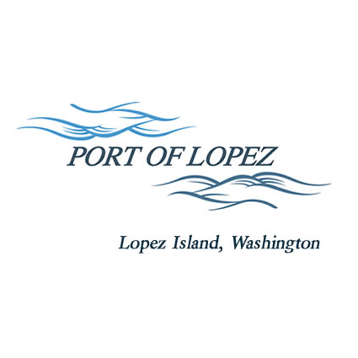

672 Airport Road, P.O. Box 907
Lopez Island, WA 98261
360.468.4116
wcatlin@portofolopez.com
www.portofolopez.com

Port of Lopez Regular Meeting Agenda

October 9th, 2025, 4:00 P.M.
This Meeting will be on Zoom and in-person at the airport terminal and on Zoom
Join Zoom Meeting
https://us02web.zoom.us/j/81256513856?pwd=Sd1b5U5Z5E0YPu01v8ffy61LME4YFI.1
Meeting ID: 812 5651 3856
Passcode: 430246

CALL TO ORDER

ONGOING BUSINESS
- DOWL Projects:
  - Beacon tilt-down pole
  - New hangar location options
- Blackwater updates
- Bayview Park Progress

PUBLIC COMMENTARY

MONTHLY BUSINESS
- Approval of Previous Minutes
- Approval of Vouchers, Payroll, and Financial Reports

MONTHLY REPORTS
- Correspondence
- Manager’s Report
- Commissioner’s Reports
- Task/Project list review

NEW BUSINESS
            - 2026 Budget Review
            - North Airport Property Discussion
            - Update Credit Card Authorizations
            - New Hangar Allocation Policy discussion
            - Lopez Housing Board Airport Wetland Mitigation Proposal
            - Formal Airport Day Debrief

AGENDA AMENDMENTS

PUBLIC COMMENTARY

EXECUTIVE SESSION: Annual Employee Performance review as per RCW 42.30.110(G)

ADJOURNMENT: Next Regular Meeting November 13th, 2025

